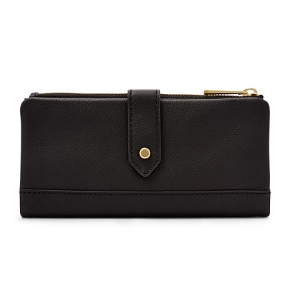

Lainie Clutch

PRODUCT DETAILS

**Silhouette: Clutch**

**Exterior Material: Leather**

**Interior Details: 1 ID Window, 2 Bill Compartments, 9 Credit Card Slots**

**Measurements: 8"L x 0.8"W x 3.7"H**

**Warranty: 1 Year Limited**